-------------------------------------------------------------

WEBTECHNOLOGY CAT II

PROJECT DOCUMENT

NAME – AJHAY .V

ROLL NUMBER - 1931004

SUBJECT – SCRIPTING LAB

SUBJECT CODE – 15MSS27

-------------------------------------------------------------

***HERE IS A LITTLE ABSTRACT ABOUT WHAT MY WEBSITE DOES….***

* With the blessings of almighty , i just created a website for booking Train tickets in INDIAN RAILWAYS . It is more a kind of IRCTC website . I‘ve built this using some BASIC HTML ,BASIC CSS AND JAVA SCRIPT CODES .

***LETS HAVE A QUICK LOOK ABOUT THE PAGES IN THE PROJECT***

* First things first , the starting page deals with dividing the screen into two halves …. The menu page and the bottom one .
* The menu page deals with almost 95% of the website contents , nothing much lets jump into the MENU PAGE .

***MENU PAGE***

* In the MENU page , it shows FIVE options for the user to go into the website… and a QR-CODE to get IRCTC APP on the mobile.

1. GALLERY
2. ALERT
3. CONTACT US
4. REGISTER
5. LOGIN

***GALLERY –*** If the user clicks on this button (option), this will take the user to the gallery page of the IRCTC , where some incredible INDIAN RAILWAY moments captured are displayed as pictures, aslo some documentary videos of INDIAN RAILWAYS is also included . Hope you will get stunned too.

***ALERT –*** ALERT PAGE just shows COVID-19 alert to all the users , I suggest the users to have a look at it . INDIAN RAILWAYS are indebted to pay respect and are on point , ensuring the safety of the PASSENGERS.

***CONTACT US -*** This page of the website displays information about the helpline numbers , customer care numbers , and numerous other services regarding COVID-19 also regarding the IR.

***REGISTER-*** This page will let us register the login account to book the tickets, (The user cannot login to book the tickets , unless He / She registers their login account).

***LOGIN –*** This page will help us login to the website , correct registered login-id and password has to be given to signin to the account , so one can book the train tickets .

***As said earlier , this page will be disabled untill the user registers his / her account.***

After logging in to the account, the user will be taken to the bookings page.

***BOOKINGS PAGE –*** This page will allow the user to check the availability of trains and book tickets. And once when the user books the ticket by filling the form , on clicking submit button , this will take the user to the PAYMENT PAGE.

***PAYMENT PAGE –*** This page will let the user to pay for the ticket(s) booked , on clicking PAY button , the payment will be complete and the user will receive their respective e-ticket through e-mail and sms and i-ticket through post service. After clicking pay the user will be taken to THANK YOU PAGE .

This is all about the menu page .

***THE BOTTOM PAGE DISPLAYS WELCOME TO INDIAN RAILWAYS .***

-------------------------------------------------------------

1. FRAME DIVISION

CODE:

<!doctype html>

<html>

<head>

<title>IRCTC NEXT GENERATION E-TICKET BOOKING SYSTEM</title>

</head>

<frameset rows="95%,5%">

<frame src="menu.html">

<frame src="down.html">

</frameset>

</html>

OUTPUT:

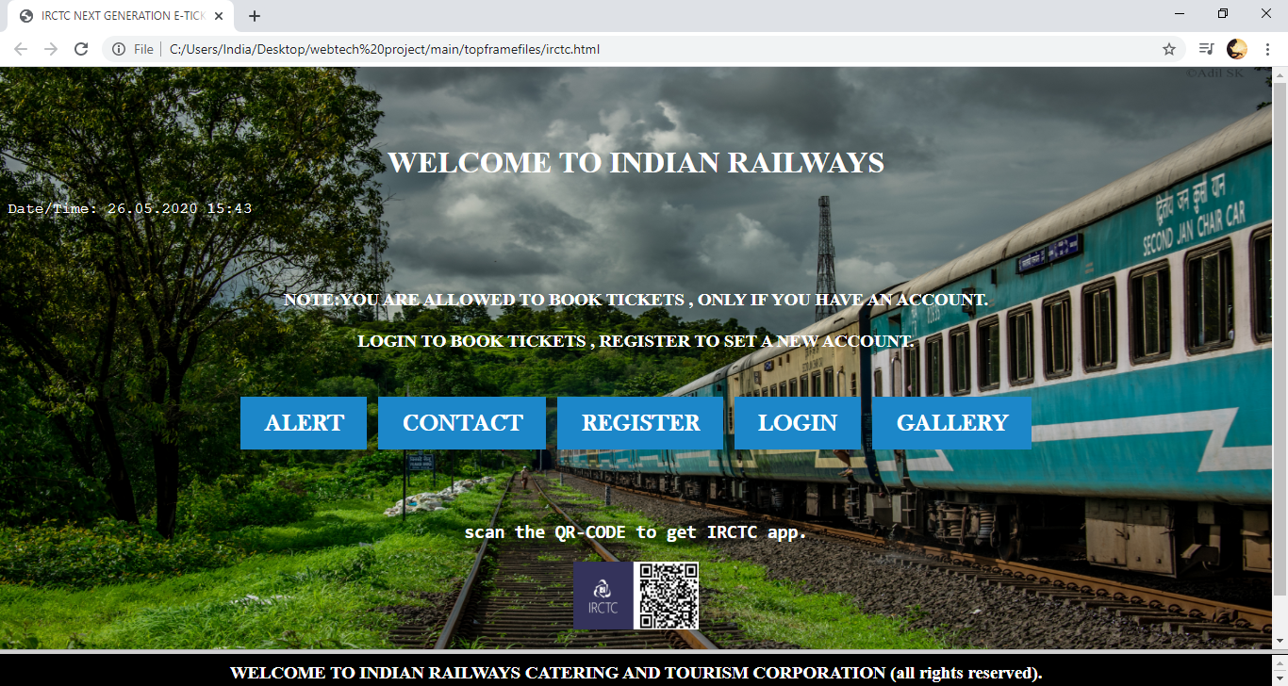

1. MENU PAGE:

CODE:

<html lang="en">

<head>

<title>menu</title>

<style>

body{

background: lightblue url("project56.jpg") no-repeat fixed center;

background-color: #cccccc;

height:90%;

background-position: fixed;

background-repeat: no-repeat;

background-size: 100% 100%;

background-attachment:fixed

position: relative;

color:white;

}

.content{

background :white;

width:50%;

padding: 40%;

margin:100% auto;

font-family:courier,arial,helvetica;

}

p{

font-size:100%;

color:white;

font-family:courier,arial,helvetica;

}

.button {

background-color: #1c87c9;

border: none;

color: white;

padding: 20px 34px;

text-align: center;

text-decoration: none;

display: inline-block;

font-size: 20px;

margin: 4px 2px;

cursor: pointer;

}

a:link,a:visited {

background-colour:hsla(0,0%,100%,0.1);

color:white;

font-size:25px;

font-family:baskerville old face;

padding:14px 25px;

text-align: center;

text-decoration:none;

display:inline-block;

position:relative;

bottom:50px;

}

a:hover,a:active

{

background-color:blue;

color:black;

font-size:25px;

font-family:baskerville old face;

padding:14px 25px;

text-align: center;

text-decoration:none;

display:inline-block;

position:relative;

bottom:50px;

}

</style>

</head>

<body>

<br>

<br>

<br>

<center><h1><b>WELCOME TO INDIAN RAILWAYS</b></h1></center>

<p>Date/Time: <span id="datetime"></span></p>

<h1><script>

var dt = new Date();

document.getElementById("datetime").innerHTML = (("0"+dt.getDate()).slice(-2)) +"."+ (("0"+(dt.getMonth()+1)).slice(-2)) +"."+ (dt.getFullYear()) +" "+ (("0"+dt.getHours()).slice(-2)) +":"+ (("0"+dt.getMinutes()).slice(-2));

</script></h1>

<br>

<br>

<p><center><h3>NOTE:YOU ARE ALLOWED TO BOOK TICKETS , ONLY IF YOU HAVE AN ACCOUNT.<BR><BR> LOGIN TO BOOK TICKETS , REGISTER TO SET A NEW ACCOUNT. </h3></Center></p>

<br>

<br>

<br>

<center><h1>&nbsp;<a href="alert.html" class="button">ALERT</a>&nbsp;<a href="contact.html" class="button">CONTACT</a>&nbsp;<a href="register.html" class="button">REGISTER</a>&nbsp;<a href="cantlogin.html" class="button">LOGIN</a>&nbsp;<a href="moments.html" class="button">GALLERY</a>&nbsp;</h1>

<center><h2><b><pre>scan the QR-CODE to get IRCTC app.</pre></b></h2></center>

<center><img src="project25.jpg" height="13%"width="10%"></center>

<center><h2><b>THANK YOU FOR USING IRCTC.</b></h2></center>

</body>

</html>

OUTPUT:

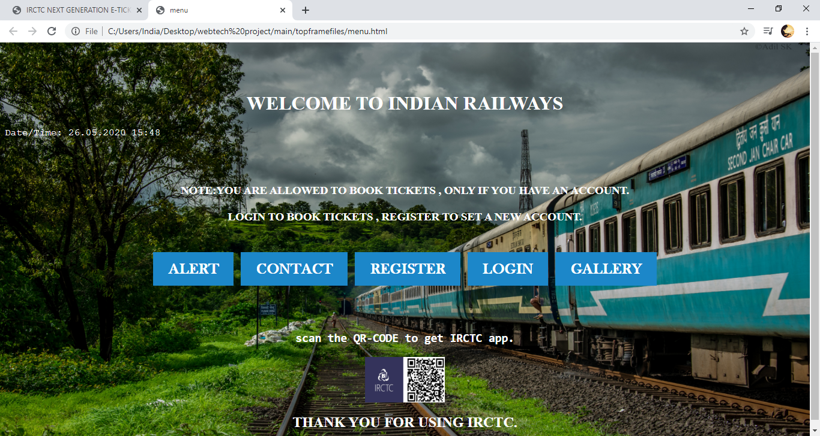

1. DOWN PAGE

CODE:

<html lang="en">

<head>

<title>menu</title>

<style>

p{

font-size:100%;

color:white;

}

</style>

<body bgcolor="black" text="white"><h3><P><center>WELCOME TO INDIAN RAILWAYS CATERING AND TOURISM CORPORATION (all rights reserved).</center></p></h3></body>

</html>

OUTPUT:

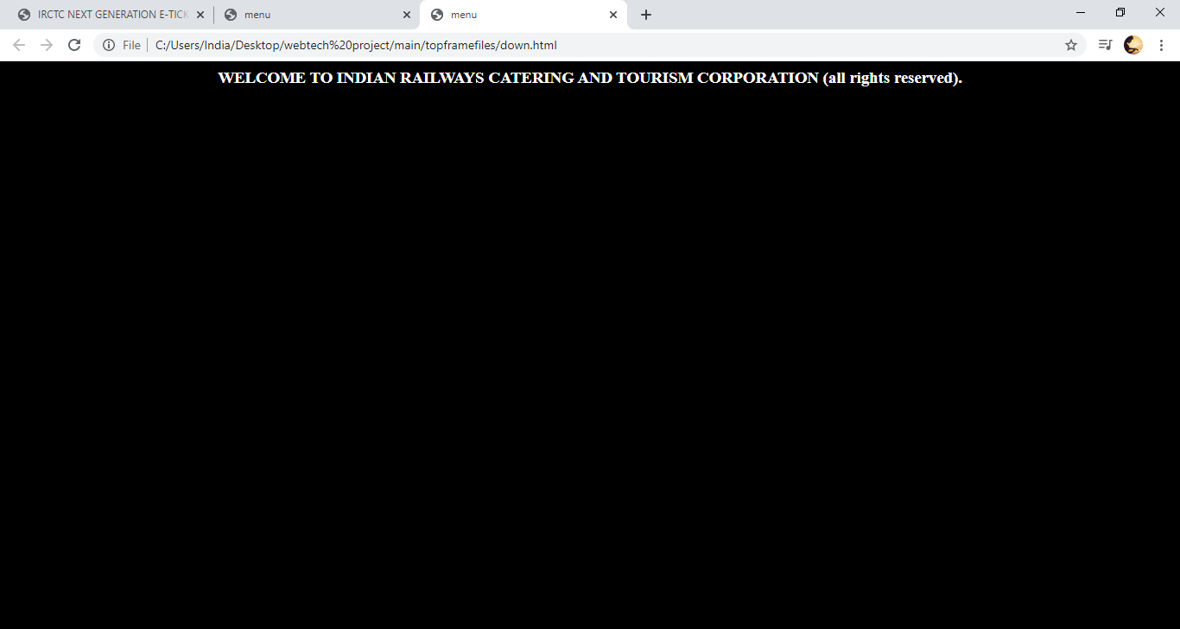

1. ALERT:

CODING:

<html>

<head>

<title>ALERT</title>

<style>

body{ background: lightblue url("project58.jpg") no-repeat fixed center;

background-color: #cccccc;

height:90%;

background-position: fixed;

background-repeat: no-repeat;

background-size: 100% 100%;

background-attachment:fixed

position: relative;

color:white;

}

.content{

background :white;

width:50%;

padding: 40%;

margin:100% auto;

font-family:calibri;

}

p{

font-size:100%;

color:white;

}

.button {

background-color: #1c87c9;

border: none;

color: white;

padding: 20px 34px;

text-align: center;

text-decoration: none;

display: inline-block;

font-size: 20px;

margin: 4px 2px;

cursor: pointer;

}

a:link,a:visited {

background-colour:hsla(0,0%,100%,0.1);

color:white;

font-size:25px;

font-family:baskerville old face;

padding:14px 25px;

text-align: center;

text-decoration:none;

display:inline-block;

position:relative;

bottom:50px;

}

a:hover,a:active

{

background-color:blue;

color:black;

font-size:25px;

font-family:baskerville old face;

padding:14px 25px;

text-align: center;

text-decoration:none;

display:inline-block;

position:relative;

bottom:50px;

}

</style>

</head>

<body bgcolor="aliceblue" text="black">

<center>

<pre><b><center><h1>COVID-19 ALERT</h1>

<marquee><h4>"WARNINING: STAY HOME STAY SAFE!"</h4></marquee>

<h2> In the wake of COVID-19 and as a measure of abundant caution, booking has been suspended for all trains until further advice.

For trains cancelled till 3rd May 2020 by Indian Railways, full refund will be provided automatically by IRCTC. Users need not cancel their e-tickets.

Full fare will be credited back into users accounts from which payment was made.</h2>

Blankets and curtains not to be available in AC coaches, other linen will continue. Please travel safely/suitably.

Inconvenience regretted.

/सीओवीआईडी-19 चेतावनी:

सीओवीआईडी -19 के मद्देनजर और प्रचुर सावधानी के उपाय के रूप में, अगली सलाह तक सभी ट्रेनों के लिए बुकिंग निलंबित कर दी गई है।

भारतीय रेलवे द्वारा 3 मई 2020 तक रद्द की गई ट्रेनों के लिए, पूर्ण वापसी आईआरसीटीसी द्वारा स्वचालित रूप से प्रदान की जाएगी। उपयोगकर्ताओं को अपने ई-टिकट को रद्द करने की आवश्यकता नहीं है। पूर्ण किराया वापस उन उपयोगकर्ताओं के खातों में जमा किया जाएगा,

जहाँ से भुगतान किया गया।

एसी कोचों में कंबल और पर्दे उपलब्ध नहीं होंगे। अन्य लिनन उपलब्ध रहेगा। कृपया सुरक्षित/ सुविधाजनक यात्रा करें। असुविधा के लिए खेद है।".

<br>

<br>

<br>

<br>

<br>

<a href="menu.html" class="button">HOME</a>

</b>

</pre>

</center>

</body>

</html>

OUTPUT:

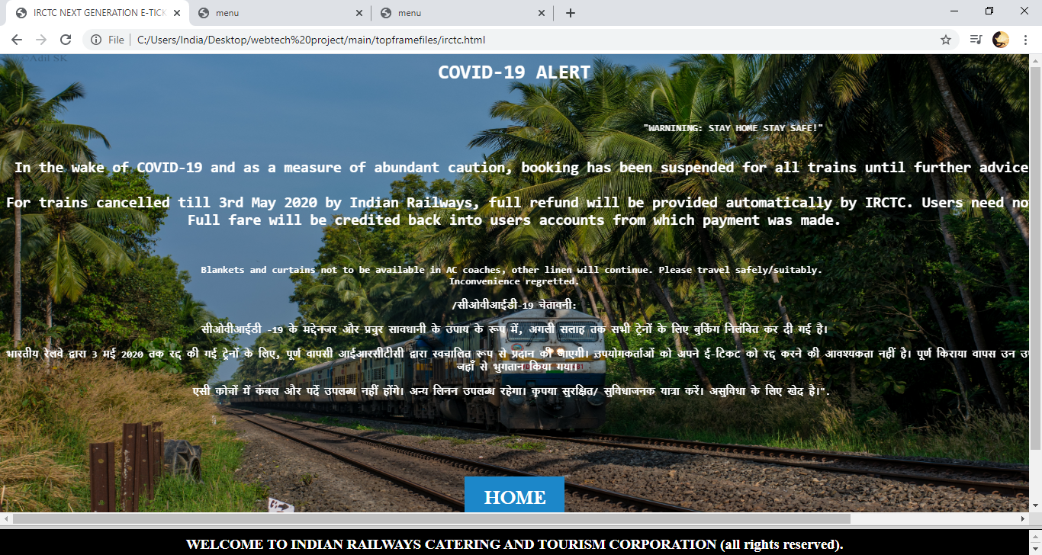

1. CONTACT US PAGE

CODE:

<html>

<head>

<title>ALERT</title>

<style>

body{ background: lightblue url("project59.jpg") no-repeat fixed center;

background-color: #cccccc;

height:90%;

background-position: fixed;

background-repeat: no-repeat;

background-size: 100% 100%;

background-attachment:fixed

position: relative;

color:white;

}

.content{

background :white;

width:50%;

padding: 40%;

margin:100% auto;

font-family:calibri;

}

p{

font-size:100%;

color:white;

}

.button {

background-color: #1c87c9;

border: none;

color: white;

padding: 20px 34px;

text-align: center;

text-decoration: none;

display: inline-block;

font-size: 20px;

margin: 4px 2px;

cursor: pointer;

}

a:link,a:visited {

background-colour:hsla(0,0%,100%,0.1);

color:white;

font-size:25px;

font-family:baskerville old face;

padding:14px 25px;

text-align: center;

text-decoration:none;

display:inline-block;

position:relative;

bottom:50px;

}

a:hover,a:active

{

background-color:blue;

color:black;

font-size:25px;

font-family:baskerville old face;

padding:14px 25px;

text-align: center;

text-decoration:none;

display:inline-block;

position:relative;

bottom:50px;

}

</style>

</head>

<body bgcolor="aliceblue" text="black">

<br>

<center><h1><b><u> CUSTOMER CARE</u></b></h1><h4>we care for you</h4></center>

<center><pre><h3>"Customer Care Numbers : 0755-6610661, 0755-4090600 (Language: Hindi and English)..

For Railway tickets booked through IRCTC

General Information

I-tickets/e-tickets : care@irctc.co.in

For Cancellation E-tickets : etickets@irctc.co.in

<br>

<br>

<br>

For IRCTC SBI Card users who do not receive the card within 01 month from the date of application kindly call on the Railway SBI Card Helpline nos.

At 0124-39021212 or 18001801295 (if calling from BSNL/MTNL line) or send email to feedback.gesbi@ge.com.

For other queries on your IRCTC SBI card account, kindly email at loyaltyprogram@irctc.co.in.

Registered Office / Corporate Office

Indian Railway Catering and Tourism Corporation Ltd.,

B-148, 11th Floor, Statesman House,

Barakhamba Road, New Delhi 110001.</h3>

<br>

<br>

<br>

<a href="menu.html" class="button">HOME</a>

</pre>

</center>

</body>

</html>

OUTPUT:

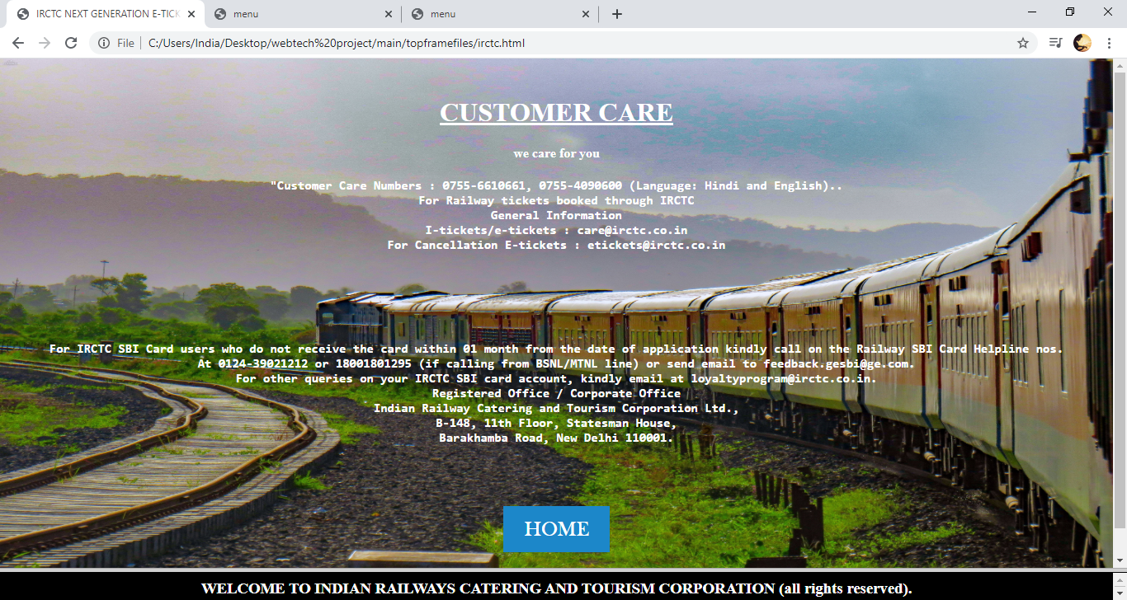

1. CANT LOGIN PAGE

CODING:

<html lang="en">

<head>

<title>CANTLOGIN</title>

<style>

body{ background: lightblue url("project57.jpg") no-repeat fixed center;

background-color:#cccccc ;

height:100%;

background-position: fixed;

background-repeat: no-repeat;

background-size: 100% 100%;

background-attachment:fixed

position: relative;

color:white;

}

.content{

background :white;

width:50%;

padding: 40%;

margin:50% auto;

font-family:baskerville old face;

}

p{

font-size:100%;

color:white;

}

.button {

background-color: #1c87c9;

border: none;

color: white;

padding: 20px 34px;

text-align: center;

text-decoration: none;

display: inline-block;

font-size: 20px;

margin: 4px 2px;

cursor: pointer;

}

a:link,a:visited {

background-colour:hsla(0,0%,100%,0.1);

color:white;

font-size:25px;

font-family:baskerville old face;

padding:14px 25px;

text-align: center;

text-decoration:none;

display:inline-block;

position:relative;

bottom:50px;

}

a:hover,a:active

{

background-color:blue;

color:black;

font-size:25px;

font-family:baskerville old face;

padding:14px 25px;

text-align: center;

text-decoration:none;

display:inline-block;

position:relative;

bottom:50px;

}

input[type=text],

select {

width: 50%;

padding: 12px 20px;

margin: 8px 0;

display: inline-block;

border: 1px solid #ccc;

border-radius: 4px;

box-sizing: border-box;

}

input[type=password],

select {

width: 50%;

padding: 12px 20px;

margin: 8px 0;

display: inline-block;

border: 1px solid #ccc;

border-radius: 4px;

box-sizing: border-box;

}

div {

border-radius: 20px;

background-color: #f2f2f200;

padding: 20px;

}

</style>

<body><h2><p><b><center>"KINDLY REGISTER YOUR ACCOUNT FIRST , TO LOGIN TO YOUR ACCOUNT"</center></b></p></h2>

<div>

<form action="menu.html" onclick="return check()" method="post">

<p><b>ENTER THE REGISTERED LOG-IN ID </b></p>

<input type="text" id="login" autofocus>

<p><b>ENTER THE PASSWORD:</b></P>

<input type="password" id="password">

<br>

<br>

<button type="submit" style="background-color:blue;font-family:baskerville old face;color:white;width:135px;

height:60px;" value="submit">HOME</button>

</form>

<br>

<br>

<br>

</div>

</body>

</html>

OUTPUT:

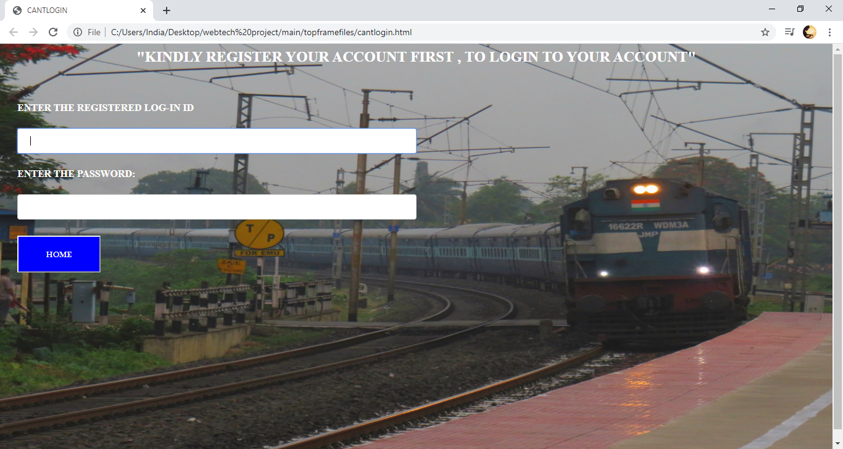

1. ACCOUNT REGISTRATION PAGE:

CODE:

<html lang="en">

<head>

<title>REGISTRATION</title>

<style>

body{ background: lightblue url("project53.jpg") no-repeat fixed center;

background-color: #cccccc;

height:90%;

background-position: fixed;

background-repeat: no-repeat;

background-size: 100% 100%;

background-attachment:fixed

position: relative;

color:white;

}

.content{

background :white;

width:50%;

padding: 40%;

margin:100% auto;

font-family:calibri;

}

p{

font-size:100%;

color:white;

font-family:courier,arial,helvetica;

}

.button {

background-color: #1c87c9;

border: none;

color: white;

padding: 20px 34px;

text-align: center;

text-decoration: none;

display: inline-block;

font-size: 20px;

margin: 4px 2px;

cursor: pointer;

}

a:link,a:visited {

background-colour:hsla(0,0%,100%,0.1);

color:white;

font-size:25px;

font-family:baskerville old face;

padding:14px 25px;

text-align: center;

text-decoration:none;

display:inline-block;

position:relative;

bottom:50px;

}

a:hover,a:active

{

background-color:blue;

color:black;

font-size:25px;

font-family:baskerville old face;

padding:14px 25px;

text-align: center;

text-decoration:none;

display:inline-block;

position:relative;

bottom:50px;

}

input[type=text], select {

width: 50%;

padding: 12px 20px;

margin: 8px 0;

display: inline-block;

border: 1px solid #ccc;

border-radius: 4px;

box-sizing: border-box;

}

input[type=password]{select {

width: 50%;

padding: 12px 20px;

margin: 8px 0;

display: inline-block;

border: 1px solid #ccc;

border-radius: 4px;

box-sizing: border-box;

}

input[type=number]{select {

width: 100%;

padding: 12px 20px;

margin: 8px 0;

display: inline-block;

border: 1px solid #ccc;

border-radius: 4px;

box-sizing: border-box;

}

input[type=submit] {

width: 100%;

background-color: #0000A0;

color: white;

padding: 14px 20px;

margin: 8px 0;

border: none;

border-radius: 4px;

cursor: pointer;

}

input[type=submit]:hover {

background-color: #0000A0;

}

div {

border-radius: 5px;

background-color: #f2f2f200;

padding: 20px;

}

</style>

<script type="text/javascript">

function validate() {

var a=document.getElementById("fname").value;

var b=document.getElementById("lname").value;

var d=document.getElementById("gender").value;

var e=document.getElementById("email").value;

var f=document.getElementById("add").value;

var h=document.getElementById("nationality").value;

var j=document.getElementById("login").value;

var k=document.getElementById("password").value;

var l=document.getElementById("retype").value;

var n=document.getElementById("captcha").value;

if(a==""){alert("enter the correct first name");return false;}

if(b=""){alert("enter the correct name");return false;}

if(d==""){alert("gender is required"); return false;}

if(e==""){alert("e-mail id is required"); return false;}

if(f==""){alert("address is required"); return false;}

if(h==""){alert ("nationality is required"); return false;}

if(j!="ajhayak"){alert("login id is required "); return false;}

if(k!="aabbccc"){alert("please choose a valid password"); return false;}

if(l!="aabbccc"){alert("retype the correct password"); return false;}

if(n!="@nM%8~9aA"){alert("enter the correct captcha"); return false;}

return true;

}

</script>

</head>

<body>

<div>

<br>

<br>

<h1><b>PLEASE FILL OUT THE ACCOUNT REGISTERATION DETAILS</b><h1>

<form onsubmit="return validate()" action="registered.html" method="post">

<h2> <legend>PERSONAL DETAILS </legend></h2>

<h6><p>FIRST NAME :</P>

<input type="text" maxlength="20" id="fname" placeholder="your first name">

<p>LAST NAME :</P>

<input type="text" maxlength="20" id="lname" placeholder="your last name">

<p>DOB :</P>

<input type="date" id="date" min="01-01-1900" placeholder="dd/mm/yyyy">

<p>GENDER (NOTE : TYPE M-MALE F-FEMALE T-TRANSGENDER O- I'D RATHER NOT SAY )</P>

<input type="text" id="gender" placeholder="M">

<p>e-MAIL :</P>

<input type="text" id="email" title="please enter a valid e mail address" placeholder="abc10@gmail.com">

<p>ADDRESS:</P>

<input type="text" id="add" placeholder="your residential address">

<p> MOBILE NUMBER :</P>

<input type="tel" id="mb" min=1000000000 max=9999999999 title="please enter a valid phone number" placeholder="please enter your phone number">

<p>NATIONALITY :</P>

<input type="text" id="nationality" placeholder="INDIAN"></h6>

<br>

<br>

<h2> <legend>CONFIDENTIAL DETAILS</legend></h2>

<h6><p> DATE OF REGISTRATION </p>

<input type="date" id="dateofregistration" required placeholder="dd/mm/yyyy"><br><br>

<label for="LOGIN-ID">LOGIN-ID</label><br><br>

<input type="text" id="login" maxlength="20"placeholder="abc123"><br><br>

<label for="PASSWORD">PASSWORD</label><br><br>

<input type="password" id="password" placeholder="Minimum 6 characters">

<p>RETYPE PASSWORD TO CONFIRM :</P>

<input type="password" id="retype" placeholder="confirm">

<p>IM NOT A ROBOT :</P>

<p>yes:</p>

<input type="radio" checked required name="type">

<p>no:</p>

<input type="radio" name="type"><br>

<label for="ENTER CAPTCHA">ENTER THE CAPTCHA SHOWN : @nM%8~9aA</label><br><br>

<input type="text" id="captcha"></h6>

<h3><p>CHECK THE DETAILS AND CLICK SUBMIT</P></h3>

<button type="submit" style="background-color:blue;font-family:baskerville old face;color:white;width:135px;

height:60px;" value="submit">REGISTER</button>

</form>

<br>

<br>

<br>

<a href="menu.html" class="button">HOME</a>

<br>

</div>

</body>

</html>

OUTPUT:

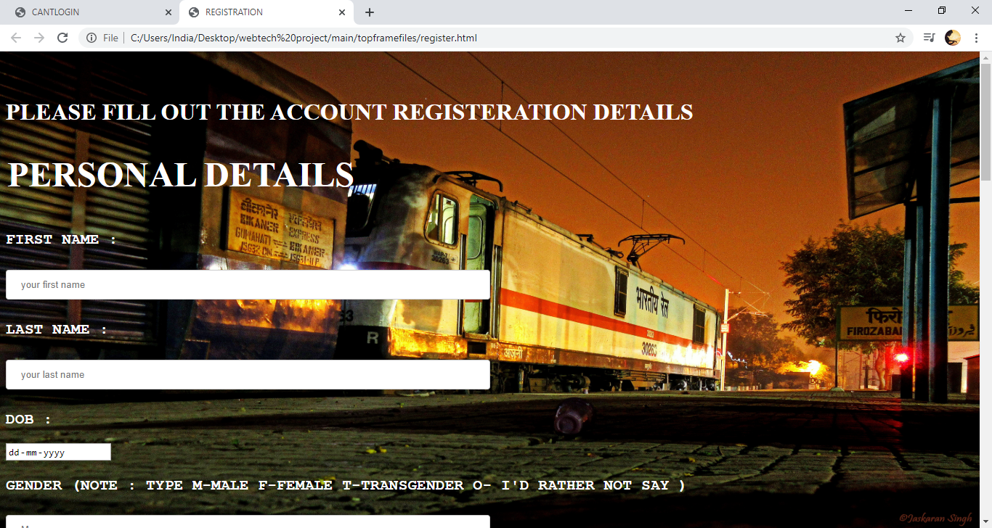

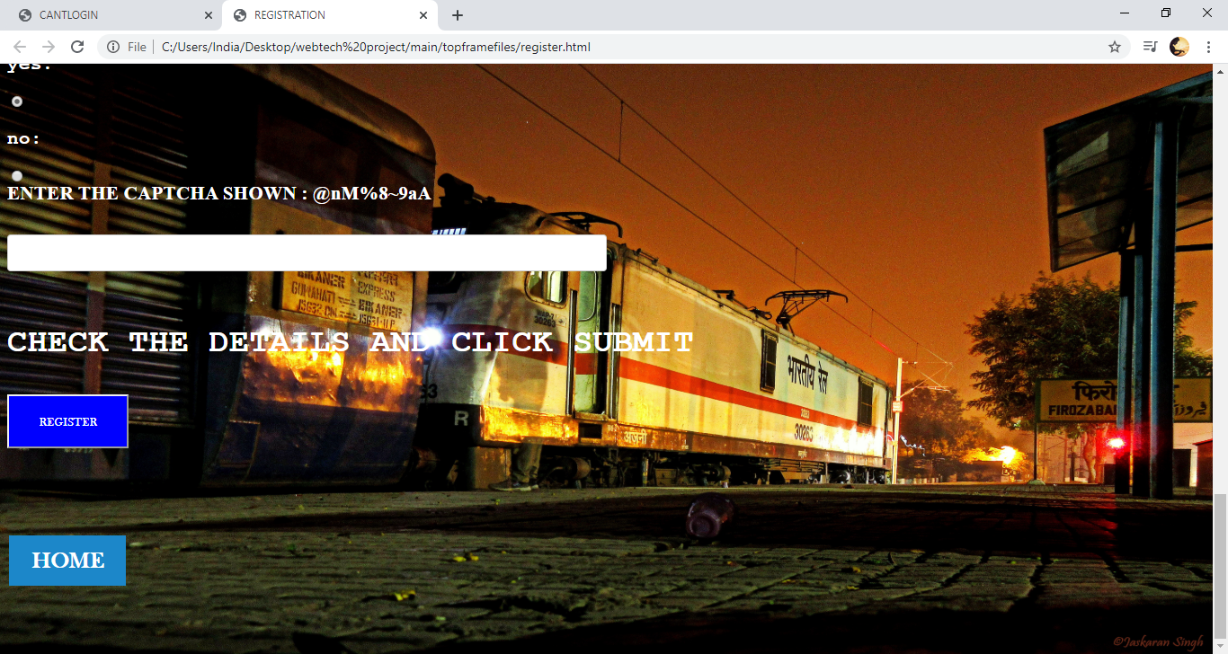

1. REGISTERED PAGE:

CODE:

<html lang="en">

<head>

<title>menu</title>

<style>

body{ background: lightblue url("project56.jpg") no-repeat fixed center;

background-color: #cccccc;

height:90%;

background-position: fixed;

background-repeat: no-repeat;

background-size: 100% 100%;

background-attachment:fixed

position: relative;

color:white;

}

.content{

background :white;

width:50%;

padding: 40%;

margin:100% auto;

font-family:calibri;

}

p{

font-size:100%;

color:white;

}

.button {

background-color: #1c87c9;

border: none;

color: white;

padding: 20px 34px;

text-align: center;

text-decoration: none;

display: inline-block;

font-size: 20px;

margin: 4px 2px;

cursor: pointer;

}

a:link,a:visited {

background-colour:hsla(0,0%,100%,0.1);

color:white;

font-size:25px;

font-family:baskerville old face;

padding:14px 25px;

text-align: center;

text-decoration:none;

display:inline-block;

position:relative;

bottom:50px;

}

a:hover,a:active

{

background-color:blue;

color:black;

font-size:25px;

font-family:baskerville old face;

padding:14px 25px;

text-align: center;

text-decoration:none;

display:inline-block;

position:relative;

bottom:50px;

}

</style>

</head>

<body>

<center><h1><b>WELCOME TO INDIAN RAILWAYS</b></h1></center>

<p>Date/Time: <span id="datetime"></span></p>

<script>

var dt = new Date();

document.getElementById("datetime").innerHTML = (("0"+dt.getDate()).slice(-2)) +"."+ (("0"+(dt.getMonth()+1)).slice(-2)) +"."+ (dt.getFullYear()) +" "+ (("0"+dt.getHours()).slice(-2)) +":"+ (("0"+dt.getMinutes()).slice(-2));

</script>

<br>

<br>

<br>

<center><p><h2><pre>REGISTRATION SUCCESSFUL , CLICK LOGIN TO BOOK TICKETS.</pre></h2></p></center>

<br>

<br>

<br>

<center><h1>&nbsp;<a href="alert.html" class="button">ALERT</a>&nbsp;<a href="contact.html" class="button">CONTACT</a>&nbsp;<a href="login.html" class="button">LOGIN</a>&nbsp;<a href="moments.html" class="button">GALLERY</a>&nbsp;</h1>

<p><center><h3><BR> LOGIN TO BOOK TICKETS , REGISTER TO SET A NEW ACCOUNT. </h3></Center></p>

<center><h2><b><pre>scan the QR-CODE to get IRCTC app.</pre></b></h2></center>

<img src="project25.jpg" height="13%"width="10%"></center>

<center><h2><b>THANK YOU FOR USING IRCTC.</b></h2></center>

</body>

</html>

OUTPUT:

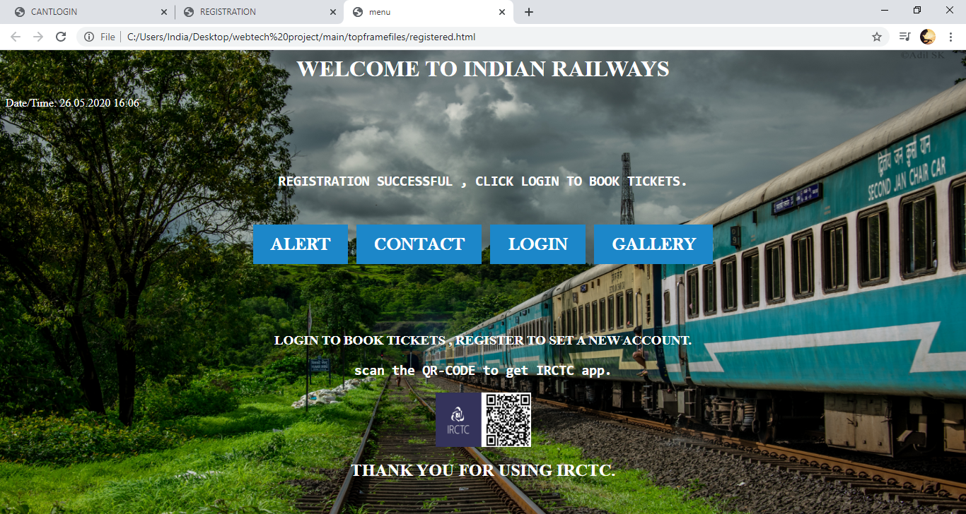

1. LOGIN PAGE

CODE:

<html lang="en">

<head>

<title>login</title>

<style>

body{ background: lightblue url("project60.jpg") no-repeat fixed center;

background-color: #cccccc;

height:90%;

background-position: fixed;

background-repeat: no-repeat;

background-size: 100% 100%;

background-attachment:fixed

position: relative;

color:white;

}

.content{

background :white;

width:50%;

padding: 40%;

margin:100% auto;

font-family:calibri;

}

.button {

background-color: #1c87c9;

border: none;

color: white;

padding: 20px 34px;

text-align: center;

text-decoration: none;

display: inline-block;

font-size: 20px;

margin: 4px 2px;

cursor: pointer;

}

a:link,a:visited {

background-colour:hsla(0,0%,100%,0.1);

color:white;

font-size:25px;

font-family:baskerville old face;

padding:14px 25px;

text-align: center;

text-decoration:none;

display:inline-block;

position:relative;

bottom:50px;

}

a:hover,a:active

{

background-color:blue;

color:black;

font-size:25px;

font-family:baskerville old face;

padding:14px 25px;

text-align: center;

text-decoration:none;

display:inline-block;

position:relative;

bottom:50px;

}

p{

font-size:100%;

color:white;

}

input[type=text],

select {

width: 50%;

padding: 12px 20px;

margin: 8px 0;

display: inline-block;

border: 1px solid #ccc;

border-radius: 4px;

box-sizing: border-box;

}

input[type=password],

select {

width: 50%;

padding: 12px 20px;

margin: 8px 0;

display: inline-block;

border: 1px solid #ccc;

border-radius: 4px;

box-sizing: border-box;

}

div {

border-radius: 5px;

background-color: #f2f2f200;

padding: 20px;

}

</style>

<script>

function validate()

{

var a=document.getElementById("login").value;

var b=document.getElementById("password").value;

if((a!="")||(b!=""))

{

if((a!="ajhayak")&&(b!="aabbccc"))

{

alert("your login-id or password is incorrect");

return false;

}

else

{

return true;

}

}

else

{

alert("your login-id or password is incorrect");

return false;

}

}

</script>

<body>

<div>

<form action="bookings.html" method="post" onclick="return validate()">

<p><b> ENTER THE REGISTERED LOG-IN ID </b></p>

<input type="text" id="login" autofocus>

<p><b>ENTER THE PASSWORD:</b></P>

<input type="password" id="password"><br>

<button type="submit" style="background-color:blue;font-family:baskerville old face;color:white;width:135px;

height:60px;" value="submit">LOGIN</button>

<br>

<br>

<br>

<br>

<br>

<a href="menu.html" class="button">HOME</a>

</form>

</div>

</body>

</html>

OUTPUT:

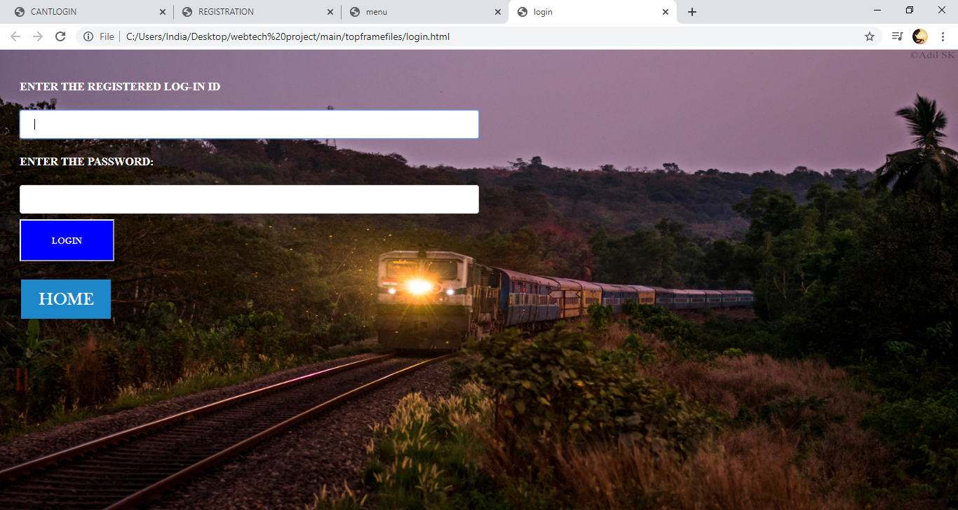

1. BOOKING PAGE

CODE:

<html lang="en">

<head>

<title>menu</title>

<style>

body{ background: lightblue url("project63.jpg") no-repeat fixed center;

background-color: #cccccc;

height:90%;

background-position: fixed;

background-repeat: no-repeat;

background-size: 100% 100%;

background-attachment:fixed

position: relative;

color:white;

}

.content{

background :white;

width:50%;

padding: 40%;

margin:100% auto;

font-family:calibri;

}

p{

font-size:100%;

color:white;

}

.button {

background-color: #1c87c9;

border: none;

color: white;

padding: 20px 34px;

text-align: center;

text-decoration: none;

display: inline-block;

font-size: 20px;

margin: 4px 2px;

cursor: pointer;

}

a:link,a:visited {

background-colour:hsla(0,0%,100%,0.1);

color:white;

font-size:25px;

font-family:baskerville old face;

padding:14px 25px;

text-align: center;

text-decoration:none;

display:inline-block;

position:relative;

bottom:50px;

}

a:hover,a:active

{

background-color:blue;

color:black;

font-size:25px;

font-family:baskerville old face;

padding:14px 25px;

text-align: center;

text-decoration:none;

display:inline-block;

position:relative;

bottom:50px;

}

input[type=text],

select {

width: 50%;

padding: 12px 20px;

margin: 8px 0;

display: inline-block;

border: 1px solid #ccc;

border-radius: 4px;

box-sizing: border-box;

}

input[type=password],

select {

width: 50%;

padding: 12px 20px;

margin: 8px 0;

display: inline-block;

border: 1px solid #ccc;

border-radius: 4px;

box-sizing: border-box;

}

div {

border-radius: 20px;

background-color: #f2f2f200;

padding: 20px;

}

input[type=text], select {

width: 50%;

padding: 12px 20px;

margin: 8px 0;

display: inline-block;

border: 1px solid #ccc;

border-radius: 4px;

box-sizing: border-box;

}

input[type=password]{select {

width: 50%;

padding: 12px 20px;

margin: 8px 0;

display: inline-block;

border: 1px solid #ccc;

border-radius: 4px;

box-sizing: border-box;

}

input[type=number]{select {

width: 100%;

padding: 12px 20px;

margin: 8px 0;

display: inline-block;

border: 1px solid #ccc;

border-radius: 4px;

box-sizing: border-box;

}

input[type=submit] {

width: 100%;

background-color: #0000A0;

color: white;

padding: 14px 20px;

margin: 8px 0;

border: none;

border-radius: 4px;

cursor: pointer;

}

input[type=submit]:hover {

background-color: #0000A0;

}

div {

border-radius: 5px;

background-color: #f2f2f200;

padding: 20px;

}

</style>

<script>

function validation() {

var a=document.getElementById("fn").value;

var b=document.getElementById("ln").value;

var c=document.getElementById("gen").value;

var d=document.getElementById("mail").value;

var e=document.getElementById("ad").value;

var f=document.getElementById("tname").value;

var g=document.getElementById("from").value;

var i=document.getElementById("to").value;

if(a==""){alert("enter the correct first name");return false;}

if(b==""){alert("enter the correct last name");return false;}

if(c==""){alert("gender is required"); return false;}

if(d==""){alert("e-mail id is required"); return false;}

if(e==""){alert("address is required"); return false;}

if(f==""){alert("train name is must "); return false;}

if(g==""){alert("from location is required"); return false;}

if(h==""){alert("to loaction is required"); return false;}

return confirm("CONFIRM BOOKING ?");

}

</script>

</head>

<body>

<br>

<br>

<br>

<br>

<h2><b><p> WARNING : <h1><center>In the wake of COVID 19 and as a measure of abundant caution, booking has been suspended for almost all trains until further advice.</center><br><center>PASSENGER SERVICES ARE OPERATED ONLY SPARSELY <br>(only 7 express trains are operated allover INDIA , this might fluctuate anyday.)</center></br></b></p></h1>

<h1><b><p><center>"we strongly recommend you to stay home stay safe , and travel only if it is neccassary"</center></p></b></h1><br>

<br><h1><center>INCONVENIENCE REGRETTED</center></h1>

<br>

<br>

<br>

<br>

<br>

<br><p>----------------------------------------------------------------------------------------------------------------------------------------------------------------------------------------------------------------------------------------------------------</p>

<p>----------------------------------------------------------------------------------------------------------------------------------------------------------------------------------------------------------------------------------------------------------</p>

<br>

<h2><b><p> AVAILABLE SERVICES ( minimum 50 seats available )</p></b></h2>

<br>

<br>

<table>

<tr>

<th>S.NO</th>

<th>TRAIN NUMBER</th>

<th>TRAIN NAME </th>

<th>FROM</th>

<th>TO</th>

<th>ARRIVAL</th>

<th>DEPARTURE</th>

<th>DESTINATION TIME</th>

<th>DAY AVAILABLE</th>

</tr>

<tr>

<th>01</th>

<th>19610</th>

<th>AJMER EXPRESS</th>

<th>AMRISTER</th>

<th>AJMER</th>

<th>14.00</th>

<th>14.30</th>

<th>10.00</th>

<th>TUESDAY</th>

</tr>

<tr>

<th>02</th>

<th>12680</th>

<th>CBE-MAS INTERCITY</th>

<th>COIMBATORE JUNCTION</th>

<th>MGR CHENNAI</th>

<th>5.55</th>

<th>6.15</th>

<th>13.30</th>

<th>DAILY</th>

</tr>

<tr>

<th>03</th>

<th>22702</th>

<th>UDHAY EXPRESS</th>

<th>VIJAYWADA JUNCTION</th>

<th>VISHAKAPATNAM JUNCTION</th>

<th>17.00</th>

<th>17.30</th>

<th>23.00</th>

<th>DAILY</th>

</tr>

<tr>

<th>04</th>

<th>06304</th>

<th>MANGLORE EXPRESS</th>

<th>NAGERCOIL</th>

<th>MANGLORE</th>

<th>20.00</th>

<th>20.35</th>

<th>11.20 (NEXTDAY)</th>

<th>DAILY(EXCEPT TUESDAY)</th>

</tr>

<tr>

<th>05</th>

<th>16616</th>

<th>CHEMOZHI EXPRESS</th>

<th>COIMBATORE</th>

<th>MANNARGUDI</th>

<th>20.00</th>

<th>20.20</th>

<th>04.45(NEXTDAY)</th>

<th>DAILY</th>

</tr>

<tr>

<th>06</th>

<th>15910</th>

<th>AVADH ASSAM EXPRESS</th>

<th>LALGARH JUNCTION</th>

<th>DELHI(RESTRICTED)</th>

<th>19.00</th>

<th>19.45</th>

<th>07.15(NEXTDAY)</th>

<th>DAILY</th>

</tr>

<tr>

<th>07</th>

<th>09313</th>

<th>ALLAHABAD EXPRESS</th>

<th>INDORE JUNCTION</th>

<th>ALLAHABAD JUNCTION</th>

<th>17.00</th>

<th>17.20</th>

<th>13.05(NEXTDAY)</th>

<th>SUNDAY ONLY</th>

</tr>

<tr>

</table>

<p><b>----------------------------------------------------------------------------------------------------------------------------------------------------------------------------------------------------------------------------------------------------------</b></p>

<p><b>----------------------------------------------------------------------------------------------------------------------------------------------------------------------------------------------------------------------------------------------------------</b></p>

<p><b><h2><u>BOOK TICKETS </u></h2></b></p>

<div>

<form action="booked.html" method="post" onclick="return validation()">

<feildset><h2> <legend><u>PERSONAL DETAILS</u><h6>(note: you receive ticket details via mail, sms to the phonenumber you provide)</legend></h2>

<h6><p>FIRST NAME :</P>

<input type="text" maxlength="20" id="fn" autofocus placeholder="your first name">

<p>MIDDLE NAME :</P>

<input type="text" maxlength="20" placeholder="your middle name(optional)">

<p>LAST NAME :</P>

<input type="text" maxlength="20" id="ln" autofocus placeholder="your last name">

<p>DOB :</P>

<input type="date" required autofocus min="01/01/1900" placeholder="dd/mm/yyyy">

<p>AGE:</P>

<input type="number" required autofocus min=18 placeholder="18">

<p>SEX (NOTE : TYPE M-MALE F-FEMALE T-TRANSGENDER O- I'D RATHER NOT SAY )</P>

<input type="text" id="gen" autofocus placeholder="M">

<p>e-MAIL :</P>

<input type="text" id="mail" autofocus title="please enter a valid e mail address" placeholder="abc10@gmail.com">

<p>ADDRESS:</P>

<input type="text" id="ad" placeholder="your residential address">

<p> MOBILE NUMBER :</P>

<input type="tel" required title="please enter a valid phone number" placeholder="please enter your phone number">

<p> AADHAR NUMBER</P>

<input type="number" id="aadhar" autofocus min=10>

<p>PAN NUMBER</P>

<input type="number" placeholder="optional">

<p>VOTER ID NUMBER</P>

<input type="number" placeholder="optional">

</feildset><br>

<p>------------------------------------------------------------------------------------------------------------------------------------------------------------------------------------------------------------------------------------------------<p>

<p>------------------------------------------------------------------------------------------------------------------------------------------------------------------------------------------------------------------------------------------------<p>

<feildset><h2><legend><u>TICKET DETAILS</u><h6>(note:Please book from available trains only)</h6></legend></h2>

<p>TICKET TYPE</P>

<input type="checkbox" name="ticket" checked>

<label for="E-TICKET"> E-TICKET</label>

<input type="checkbox" name="ticket">

<label for="I-TICKET">I-TICKET</label>

<p>TRAIN NAME</P>

<input type="TEXT" id="tname" autofocus>

<p>TRAIN NUMBER:</P>

<input type="number" required autofocus>

<P>FROM</P>

<input type="TEXT" id="from" autofocus>

<P>TO</P>

<input type="TEXT" id="to" autofocus>

<p> DATE OF JOURNEY </p>

<input type="date" required placeholder="dd/mm/yyyy"><br>

<p>TOTAL MEMBERS</P>

<input type="number" required autofocus min="1" placeholder="1">

<P><B>ENTER THE NAME , GENDER , AGE AND ABILITY STATUS OF THE MEMBER(S) <BR> <h5>FORMAT: 1.GEORGE,MALE,18,ABLED . ( FORMAT MUST STRICTLY BE FOLLOWED.USE UPPER CASE . ) </h5></B></P>

<input type="TEXT" required autofocus min="1" placeholder="1.GEORGE,MALE,18,ABLED">

<P>COACH PREFERANCE</P>

<input type="checkbox" name="pre"id="1st AC">

<label for="1st AC"> 1st AC</label>

<input type="checkbox" name="pre"id="2ND AC">

<label for="2ND AC"> 2ND AC</label>

<input type="checkbox" name="pre" id="SLEEPER" autofocus checked>

<label for="SLEEPER">SLEEPER</label>

<input type="checkbox" name="pre" id="UR">

<label for="UR">UR</LABEL>

<p>BIRTH PREFERENCE</P>

<input type="checkbox" name="birth" id="WINDOWSIDE" checked>

<label for="WINDOWSIDE"> WINDOWSIDE</label>

<input type="checkbox" name="birth" id="MIDDLE">

<label for="MIDDLE"> MIDDLE</label>

<input type="checkbox" name="birth" id="LOWER">

<label for="LOWER">LOWER</label>

<P>BOOK?</P>

<button type="book" style="background-color:blue;font-family:baskerville old face;color:white;width:169px;

height:60px;" value="book">BOOK NOW</button>

</form>

<br>

<br>

<br>

<a href="registered.html" class="button">SIGNOUT</a>

</feildset>

</form>

</div>

</body>

</html

OUTPUT:

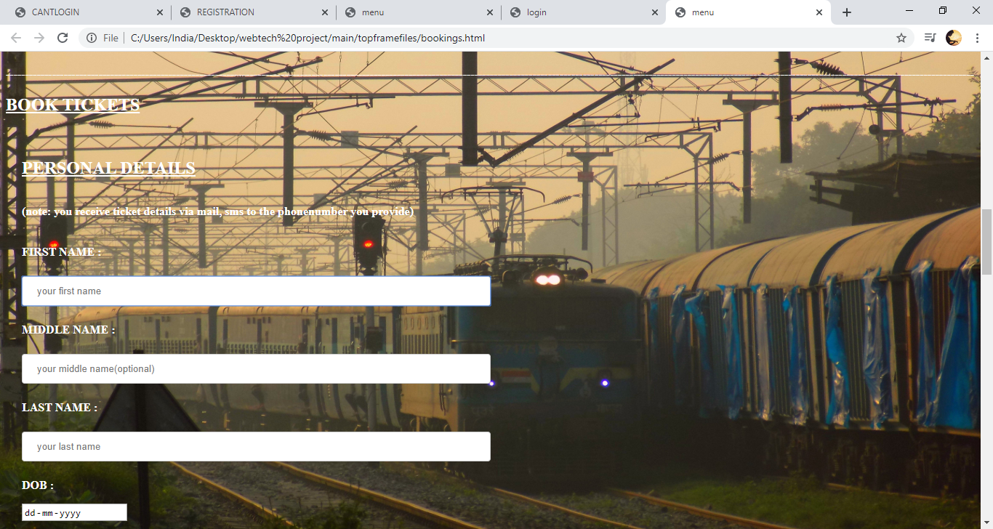

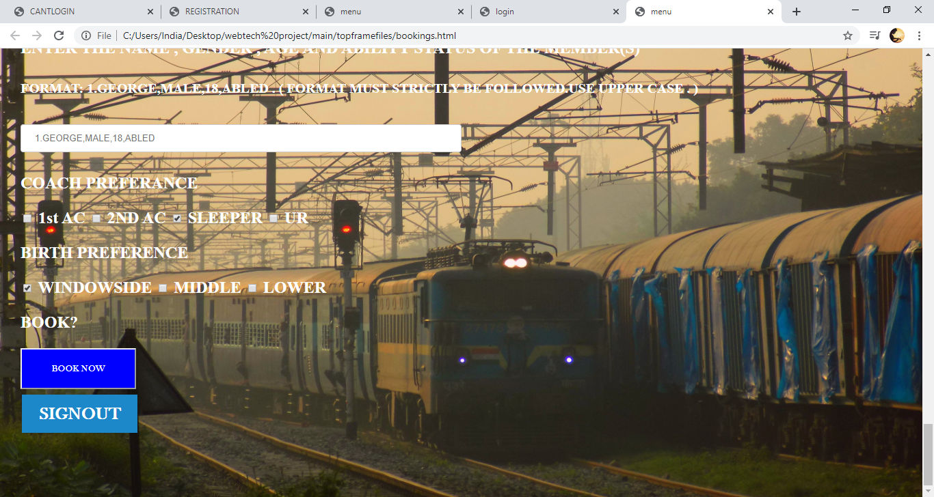

1. PAYMENT PAGE

CODE:

<html lang="en">

<head>

<title>menu</title>

<style>

body{ background: lightblue url("project61.jpg") no-repeat fixed center;

background-color: #cccccc;

height:90%;

background-position: fixed;

background-repeat: no-repeat;

background-size: 100% 100%;

background-attachment:fixed

position: relative;

color:white;

}

.content{

background :white;

width:50%;

padding: 40%;

margin:100% auto;

font-family:calibri;

}

p{

font-size:100%;

color:white;

}

.button {

background-color: #1c87c9;

border: none;

color: white;

padding: 20px 34px;

text-align: center;

text-decoration: none;

display: inline-block;

font-size: 20px;

margin: 4px 2px;

cursor: pointer;

}

a:link,a:visited {

background-colour:hsla(0,0%,100%,0.1);

color:white;

font-size:25px;

font-family:baskerville old face;

padding:14px 25px;

text-align: center;

text-decoration:none;

display:inline-block;

position:relative;

bottom:50px;

}

a:hover,a:active

{

background-color:blue;

color:black;

font-size:40px;

font-family:baskerville old face;

padding:14px 25px;

text-align: center;

text-decoration:none;

display:inline-block;

position:relative;

bottom:50px;

}

input[type=text],

select {

width: 50%;

padding: 12px 20px;

margin: 8px 0;

display: inline-block;

border: 1px solid #ccc;

border-radius: 4px;

box-sizing: border-box;

}

input[type=password],

select {

width: 50%;

padding: 12px 20px;

margin: 8px 0;

display: inline-block;

border: 1px solid #ccc;

border-radius: 4px;

box-sizing: border-box;

}

div {

border-radius: 20px;

background-color: #f2f2f200;

padding: 20px;

}

input[type=text], select {

width: 50%;

padding: 12px 20px;

margin: 8px 0;

display: inline-block;

border: 1px solid #ccc;

border-radius: 4px;

box-sizing: border-box;

}

input[type=password]{select {

width: 50%;

padding: 12px 20px;

margin: 8px 0;

display: inline-block;

border: 1px solid #ccc;

border-radius: 4px;

box-sizing: border-box;

}

input[type=number]{select {

width: 100%;

padding: 12px 20px;

margin: 8px 0;

display: inline-block;

border: 1px solid #ccc;

border-radius: 4px;

box-sizing: border-box;

}

input[type=submit] {

width: 100%;

background-color: #0000A0;

color: white;

padding: 14px 20px;

margin: 8px 0;

border: none;

border-radius: 4px;

cursor: pointer;

}

input[type=submit]:hover {

background-color: #0000A0;

}

div {

border-radius: 5px;

background-color: #f2f2f200;

padding: 20px;

}

</style>

</head>

<body>

<br>

<br>

<br>

<p><h1>-----------------------------------------------------------------------------------------------------------------------------</h1></p>

<p><h1>-----------------------------------------------------------------------------------------------------------------------------</h1></p>

<center><h1><b><button style="background-color:silver;font-family:baskerville old face;color:black;font-size:30px;width:300px;

height:150px;" value="book">TICKET COST : 400.00 Rs Only </button></b></h1></center>

<p><h1>-----------------------------------------------------------------------------------------------------------------------------</h1></p>

<p><h1>-----------------------------------------------------------------------------------------------------------------------------</h1></p>

<p><b><h1> PAYMENT SECTION </h1></b></p>

<p><b><h3> NOTE: USER CAN HAVE MINIMUM OF 6 BANKS IN THE PREFERANCE LIST , THEY CAN MANAGE THEIR BANK PREFERANCE IN THE MY PROFILE SECTION IN THE IRCTC APP .</h3></b></p>

<div class="row">

<div class="col-75">

<div class="container">

<form action="thankyou.html" method="post">

<div class="row">

<div class="col-50">

<h3>TICKET ADDRESS</h3>

<h2>

<label for="fname">Full Name</label><br>

<input type="text" id="fname" name="firstname" required placeholder="george"><br>

<label for="email">Email</label><br>

<input type="text" id="email" name="email" required placeholder="abc.123@gmail.com"><br>

<label for="adr"> Address</label><br>

<input type="text" id="adr" name="address" required required><br>

<label for="state">State</label><br>

<input type="text" id="state" name="state" required ><br>

</div>

<div class="col-50">

<label for="pincode">Zip</label><br>

<input type="text" required name="zip" required placeholder="10001">

<label for="fname">Accepted Cards</label>

<P> PAYMENT CARD PREFERANCE</P>

<input type="checkbox" name="card">

<label for="VISA"> VISA</label>

<input type="checkbox" name="card" autofocus checked>

<label for="MASTERO CARD"> MASTERO CARD</label>

<input type="checkbox" name="card" autofocus>

<label for="DISCOVER">DISCOVER</label>

<input type="checkbox" name="card">

<label for="AMEX">AMEX</LABEL>

<p><h5>"WE STRONGLY RECCOMMEND YOU TO CHECK THE BALANCE BEFORE SELECTING THE CARD OPTION"</h5></p>

<label for="cname">Name on Card</label><br>

<input type="text" id="cname" name="cardname" required placeholder=""><br>

<label for="cnum">Credit card number</label><br>

<input type="text" id="ccnum" name="cardnumber" required placeholder="George"><br>

<label for="expmonth">Exp Month</label><br>

<input type="text" id="expmonth" name="expmonth" required placeholder="September"><br>

<label for="expyear">Exp Year</label><br>

<input type="number" id="expyear" name="expyear" required placeholder="2025"><br>

<br>

<label for="cvv">CVV</label><br>

<input type="text" id="cvv" name="cvv" required placeholder="352"></h2><br>

<label for="ENTER CAPTCHA">ENTER THE CAPTCHA SHOWN : <h2>$jkc5i*</h2></label><br><br>

<input type="text" id="captcha" required></h6>

</div>

</div>

</div>

<br>

<button type="booked" style="background-color:blue;font-family:baskerville old face;color:white;width:169px;

height:60px;" value="book">PAY</button>

<br>

</form>

<br>

<br>

<br>

<a href="bookings.html" class="button">GO BACK TO BOOKING PAGE</a>

<br>

<a href="registered.html" class="button">SIGNOUT</a>

</div>

</div>

</div>

<p><h1>-----------------------------------------------------------------------------------------------------------------------------</h1></p>

<p><h1>-----------------------------------------------------------------------------------------------------------------------------</h1></p>

<h2><b><p>WARNING:In the wake of COVID 19 and as a measure of abundant caution, booking has been suspended for almost all trains until further advice. <br>

<br>

<br>PASSENGER SERVICES ARE OPERATED ONLY SPARSELY (only 7 express trains are operated allover INDIA , this might fluctuate anyday.)</b></p></h2>

<h2><b><p><br>"we strongly recommend you to stay home stay safe , and travel only if it is neccassary"</p></b></h2><h1>INCONVENIENCE REGRETTED.</h1>

<p><h1>-----------------------------------------------------------------------------------------------------------------------------</h1></p>

<p><h1>-----------------------------------------------------------------------------------------------------------------------------</h1></p>

</body>

</html>

OUTPUT:

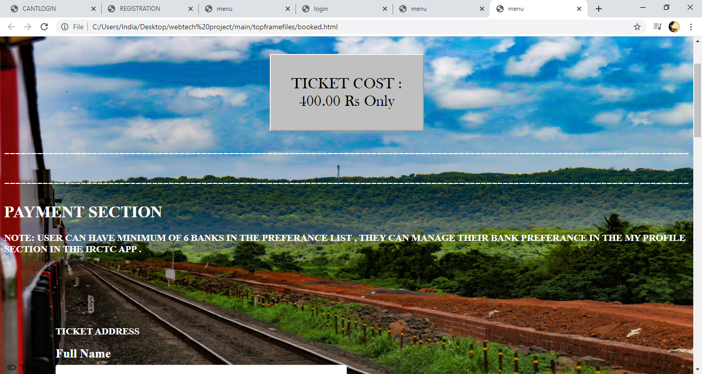

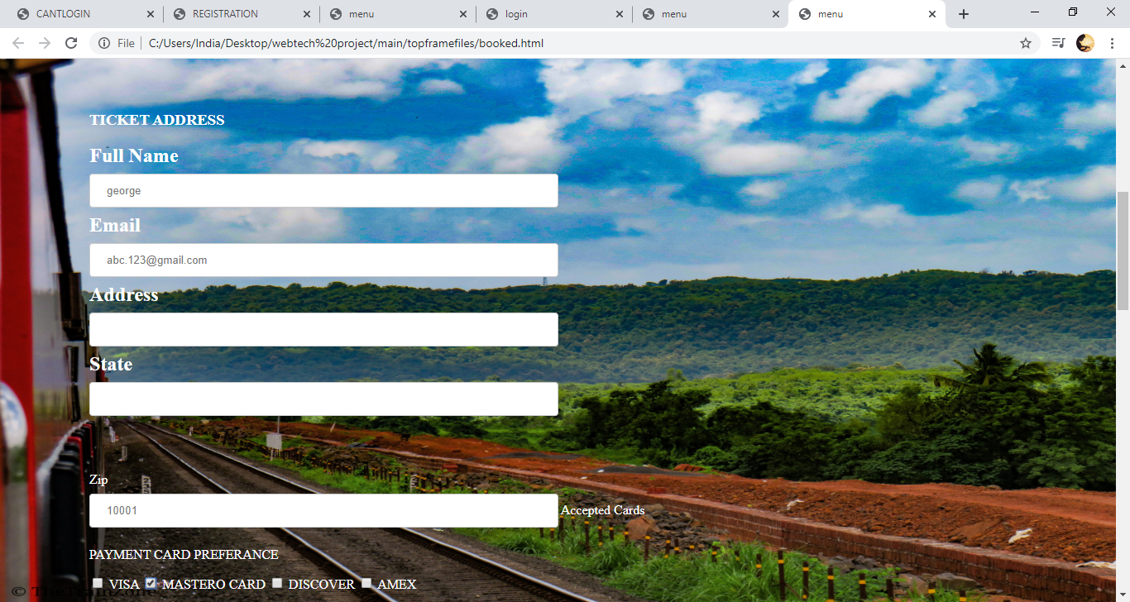

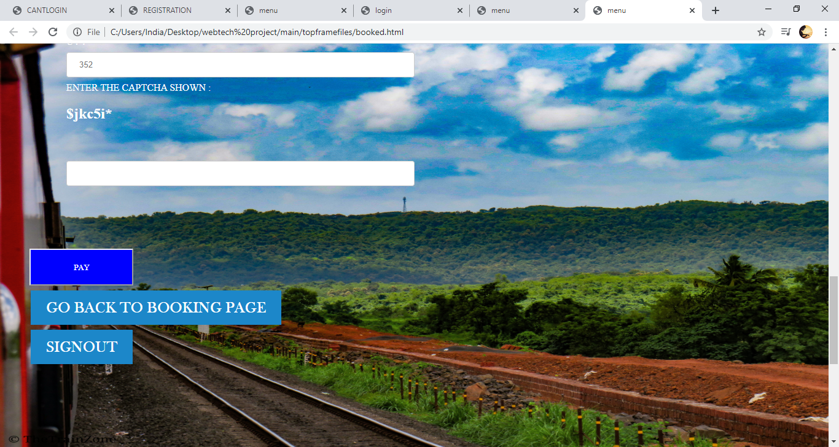

1. THANK YOU PAGE

CODE:

<html lang="en">

<head>

<title>menu</title>

<style>

body{ background: lightblue url("project55.jpg") no-repeat fixed center;

background-color: #cccccc;

height:90%;

background-position: fixed;

background-repeat: no-repeat;

background-size: 100% 100%;

background-attachment:fixed

position: relative;

color:white;

}

.content{

background :white;

width:50%;

padding: 40%;

margin:100% auto;

font-family:calibri;

}

p{

font-size:100%;

color:black;

}

.button {

background-color: #1c87c9;

border: none;

color: white;

padding: 20px 34px;

text-align: center;

text-decoration: none;

display: inline-block;

font-size: 20px;

margin: 4px 2px;

cursor: pointer;

}

a:link,a:visited {

background-colour:hsla(0,0%,100%,0.1);

color:white;

font-size:25px;

font-family:baskerville old face;

padding:14px 25px;

text-align: center;

text-decoration:none;

display:inline-block;

position:relative;

bottom:50px;

}

a:hover,a:active

{

background-color:blue;

color:black;

font-size:25px;

font-family:baskerville old face;

padding:14px 25px;

text-align: center;

text-decoration:none;

display:inline-block;

position:relative;

bottom:50px;

}

</style>

</head>

<body>

<br>

<br>

<br>

<br>

<br>

<br>

<p><center><h1> TRANSACTION COMPLETE CHECK THE SMS , MAIL ID FOR THE TICKET!</h1></center>

<br>

<br>

<center><h2> THANK YOU FOR USING INDIAN RAILWAYS </h2></center>

<br>

<br>

<center><h2> happy journey,we wish you a safe journey! </h2></center>

<br>

<br>

<center><h2><b><pre>scan the QR-CODE to get IRCTC app.</pre></b></h2></center></p>

<br>

<center><img src="project25.jpg" height="13%"width="10%"></center>

<br>

<br>

<br>

<br>

<center><a href="menu.html" class="button">SIGNOUT</a></center>

</body>

</html>

OUTPUT:

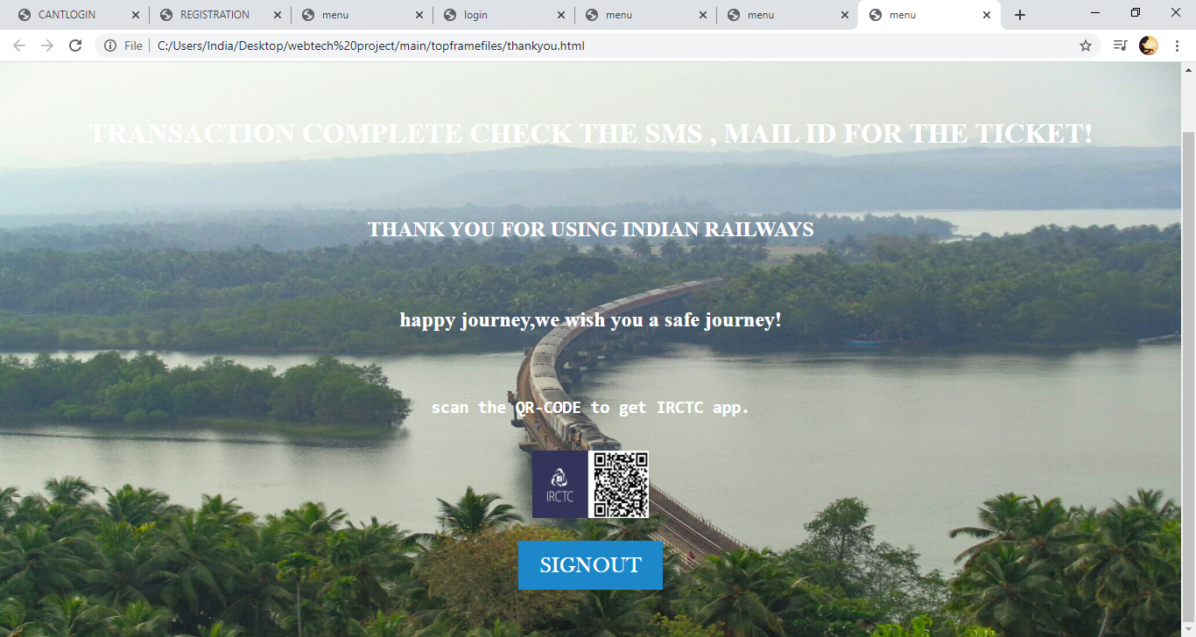

1. GALLERY PAGE

CODE:

<html lang="en" dir="ltr">

<head>

<title>MOMENTS</title>

<style>

body{

background: lightblue url("project66.jpg") no-repeat fixed center;

background-color: #cccccc;

height:90%;

background-position: fixed;

background-repeat: no-repeat;

background-size: 100% 100%;

background-attachment:fixed

position: relative;

color:white;

}

.button {

background-color: #1c87c9;

border: none;

color: white;

padding: 20px 34px;

text-align: center;

text-decoration: none;

display: inline-block;

font-size: 20px;

margin: 4px 2px;

cursor: pointer;

}

a:link,a:visited {

background-colour:hsla(0,0%,100%,0.1);

color:white;

font-size:25px;

font-family:baskerville old face;

padding:14px 25px;

text-align: center;

text-decoration:none;

display:inline-block;

position:relative;

bottom:50px;

}

a:hover,a:active

{

background-color:blue;

color:black;

font-size:25px;

font-family:baskerville old face;

padding:14px 25px;

text-align: center;

text-decoration:none;

display:inline-block;

position:relative;

bottom:50px;

}

</style>

</head>

<body>

<br>

<br>

<br>

<br>

<br>

<br>

<br>

<br>

<br>

<br>

<br>

<h1><center><h1><a href="photos.html" class="button">PHOTOS</a>&nbsp;<a href="videos.html" class="button">VIDEOS</a>&nbsp;<a href="menu.html" class="button">HOME</a>&nbsp;</center></h1>

</body>

</html>

OUTPUT:

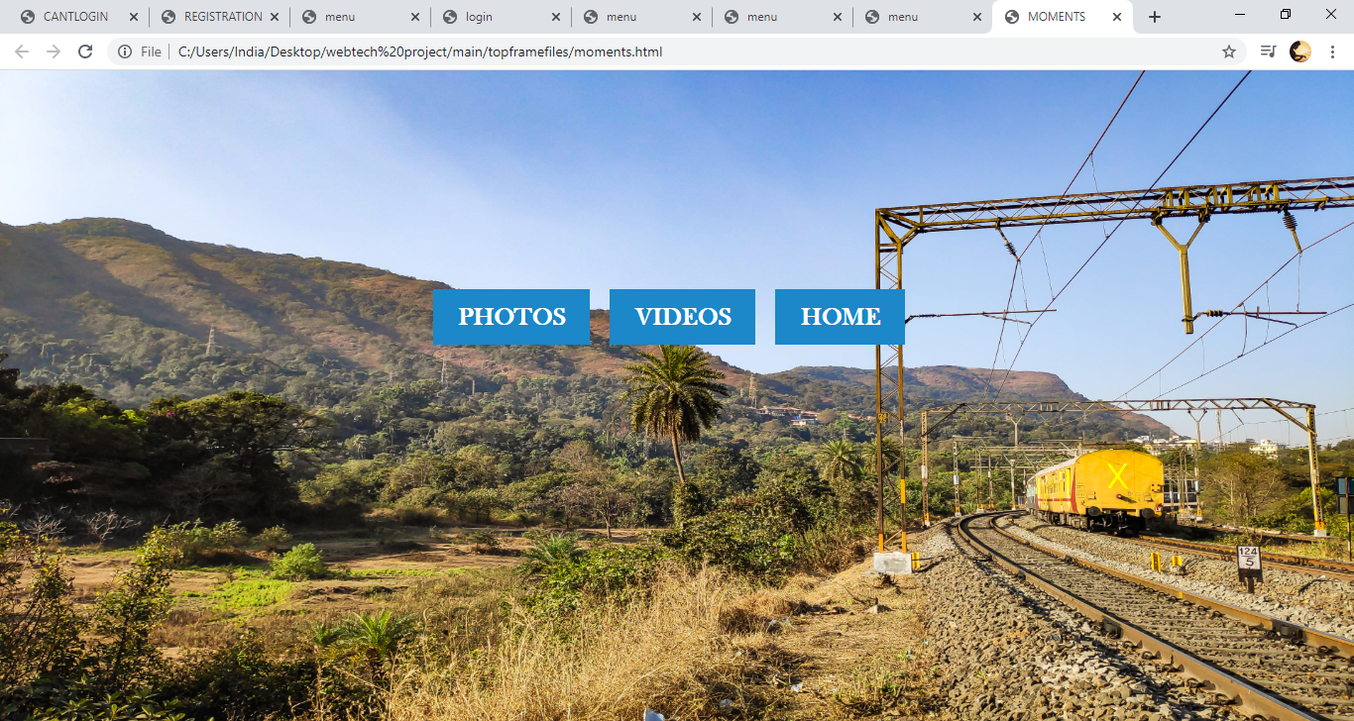

1. PHOTOS

CODE:

<html lang="en" dir="ltr">

<head>

<title>PHOTOS OF IR</title>

<style>

.button {

background-color: #1c87c9;

border: none;

color: white;

padding: 20px 34px;

text-align: center;

text-decoration: none;

display: inline-block;

font-size: 20px;

margin: 4px 2px;

cursor: pointer;

}

a:link,a:visited {

background-colour:hsla(0,0%,100%,0.1);

color:white;

font-size:25px;

font-family:baskerville old face;

padding:14px 25px;

text-align: center;

text-decoration:none;

display:inline-block;

position:relative;

bottom:50px;

}

a:hover,a:active

{

background-color:blue;

color:black;

font-size:25px;

font-family:baskerville old face;

padding:14px 25px;

text-align: center;

text-decoration:none;

display:inline-block;

position:relative;

bottom:50px;

}

</style>

</head>

<body bgcolor="black" text="white">

<center><p></b><H2>SOME OF THE EPIC MOMENTS CAPTURED FROM INDIAN RAILWAYS </H2></B></p>

<img src="43.jpg" alt="" height="30%" width="30%">

<img src="2.jpg" alt="" height="30%" width="30%">

<img src="1.jpg" alt="" height="30%" width="30%">

<img src="4.jpg" alt="" height="30%" width="30%">

<img src="5.jpg" alt="" height="30%" width="30%">

<img src="project63.jpg" alt="" height="30%" width="30%">

<img src="7.jpg" alt="" height="30%" width="30%">

<img src="8.jpg" alt="" height="30%" width="30%">

<img src="9.jpg" alt="" height="30%" width="30%">

<img src="10.jpg" alt="" height="30%" width="30%">

<img src="11.jpg" alt="" height="30%" width="30%">

<img src="12.jpg" alt="" height="30%" width="30%">

<img src="13.jpg" alt="" height="30%" width="30%">

<img src="14.jpg" alt="" height="30%" width="30%">

<img src="15.jpg" alt="" height="30%" width="30%">

<img src="16.jpg" alt="" height="30%" width="30%">

<img src="17.jpg" alt="" height="30%" width="30%">

<img src="18.jpg" alt="" height="30%" width="30%">

<img src="19.jpg" alt="" height="30%" width=30%">

<img src="20.jpg" alt="" height="30%" width="30%">

<img src="project1.jpg" alt="" height="30%" width="30%">

<img src="project2.jpg" alt="" height="30%" width="30%">

<img src="project3.jpg" alt="" height="30%" width="30%">

<img src="project4.jpg" alt="" height="30%" width="30%">

<img src="project5.jpg" alt="" height="30%" width="30%">

<img src="project11.jpg" alt="" height="30%" width="30%">

<img src="project12.jpg" alt="" height="30%" width="30%">

<img src="project13.jpg" alt="" height="30%" width="30%">

<img src="project14.jpg" alt="" height="30%" width="30%">

<img src="project15.jpg" alt="" height="30%" width="30%">

<img src="project16.jpg" alt="" height="30%" width="30%">

<img src="project21.jpg" alt="" height="30%" width="30%">

<img src="project22.jpg" alt="" height="30%" width="30%">

<img src="project26.jpg" alt="" height="30%" width="30%">

<img src="project27.jpg" alt="" height="30%" width="30%">

<img src="project28.jpg" alt="" height="30%" width="30%">

<img src="project29.jpg" alt="" height="30%" width="30%">

<img src="project30.jpg" alt="" height="30%" width="30%">

<img src="project31.jpg" alt="" height="30%" width="30%">

<img src="project32.jpg" alt="" height="30%" width="30%">

<img src="project33.jpg" alt="" height="30%" width="30%">

<img src="project34.jpg" alt="" height="30%" width="30%">

<img src="project35.jpg" alt="" height="30%" width="30%">

<img src="project36.jpg" alt="" height="30%" width="30%">

<img src="project39.jpg" alt="" height="30%" width="30%">

<img src="project40.jpg" alt="" height="30%" width="30%">

<img src="project41.jpg" alt="" height="30%" width="30%">

<img src="project42.jpg" alt="" height="30%" width="30%">

<img src="project50.jpeg" alt="" height="30%" width="30%">

<img src="project52.jpg" alt="" height="30%" width="30%">

<img src="project53.jpg" alt="" height="30%" width="30%">

<img src="project54.jpg" alt="" height="30%" width="30%">

<img src="project55.jpg" alt="" height="30%" width="30%">

<img src="project56.jpg" alt="" height="30%" width="30%">

<img src="project57.jpg" alt="" height="30%" width="30%">

<img src="project58.jpg" alt="" height="30%" width="30%">

<img src="project59.jpg" alt="" height="30%" width="30%">

<img src="project60.jpg" alt="" height="30%" width="30%">

<img src="project61.jpg" alt="" height="30%" width="30%">

<img src="project62.jpg" alt="" height="30%" width="30%">

<p></b><H1>..........THE BEAUTY OF GREAT INDIAN RAILWAYS..........</H1></B></p>

<br>

<br>

<br>

<a href="menu.html" class="button">HOME</a>

</center>

</body>

</html>

OUTPUT:

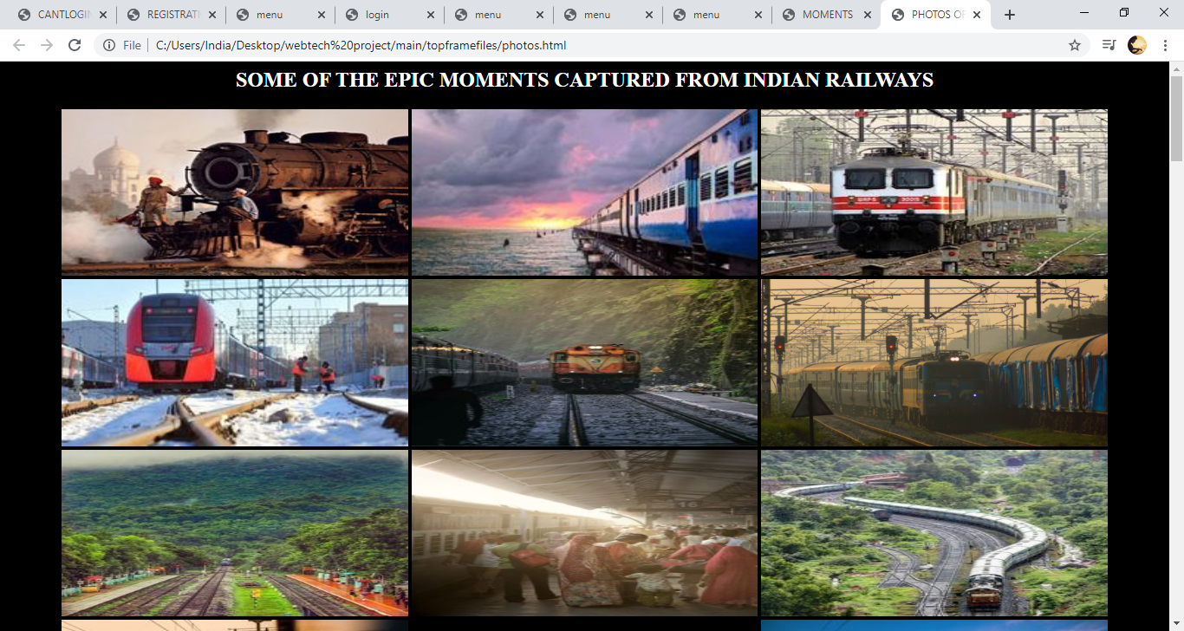

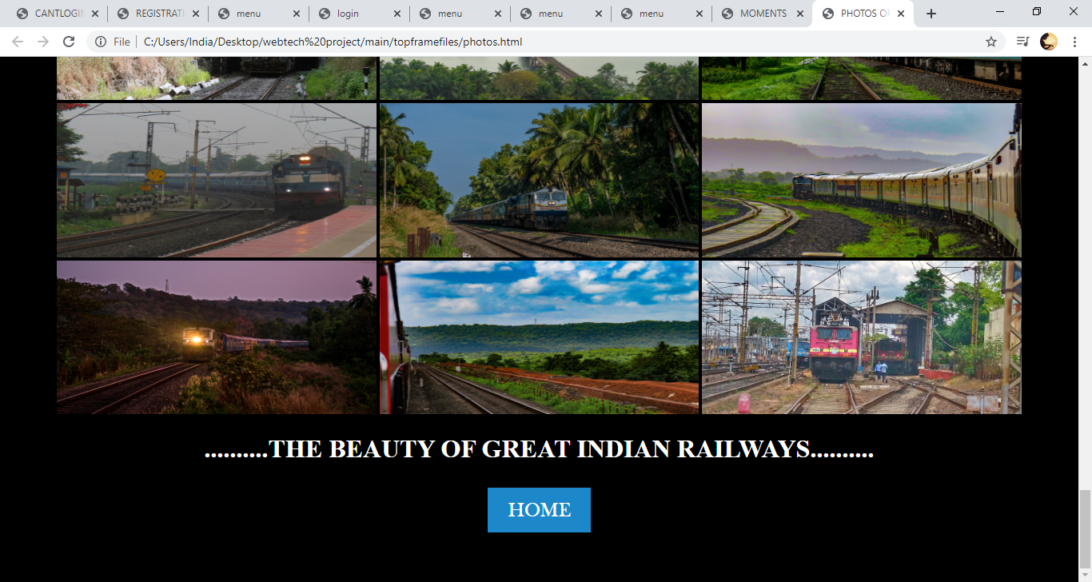

1. VIDEOS PAGE:

CODE:

<html lang="en">

<head>

<title>menu</title>

<style>

body{

background: lightblue url("project65.jpg") no-repeat fixed center;

background-color: #cccccc;

height:90%;

background-position: fixed;

background-repeat: no-repeat;

background-size: 100% 100%;

background-attachment:fixed

position: relative;

color:white;

}

p{

font-size:200%;

color:white;

font-family:courier,arial,helvetica;

}

* {

box-sizing: border-box;

}

body {

margin: 0;

font-family: Arial;

font-size: 17px;

}

#myVideo {

position: fixed;

right: 0;

bottom: 0;

min-width: 100%;

min-height: 100%;

}

.content {

position: fixed;

bottom: 0;

background: rgba(0, 0, 0, 0.5);

color: #f1f1f1;

width: 100%;

padding: 20px;

}

#myBtn {

width: 200px;

font-size: 50px;

padding: 10px;

border: none;

background:blue;

color: blue;

cursor: pointer;

}

#myBtn:hover {

background: blue;

color: black;

}

.button {

background-color: #1c87c9;

border: none;

color: white;

padding: 20px 34px;

text-align: center;

text-decoration: none;

display: inline-block;

font-size: 20px;

margin: 4px 2px;

cursor: pointer;

}

a:link,a:visited {

background-colour:hsla(0,0%,100%,0.1);

color:white;

font-size:25px;

font-family:baskerville old face;

padding:14px 25px;

text-align: center;

text-decoration:none;

display:inline-block;

position:relative;

bottom:50px;

}

a:hover,a:active

{

background-color:blue;

color:black;

font-size:25px;

font-family:baskerville old face;

padding:14px 25px;

text-align: center;

text-decoration:none;

display:inline-block;

position:relative;

bottom:50px;

</style>

</head>

<br>

<br>

<br>

<center><h1><p><b><u> DOCUMENTARY OF INDIAN RAILWAYS</u></b></p></h1></center>

<br>

<center><iframe width="853" height="480" src="https://www.youtube.com/embed/HkKtU5JxCtM" frameborder="0" allow="accelerometer; autoplay; encrypted-media; gyroscope; picture-in-picture" allowfullscreen></iframe></center>

<br>

<br>

<center><iframe width="853" height="480" src="https://www.youtube.com/embed/gPI4pHuBnYA" frameborder="0" allow="accelerometer; autoplay; encrypted-media; gyroscope; picture-in-picture" allowfullscreen></iframe></center>

<br>

<br>

<center><iframe width="853" height="480" src="https://www.youtube.com/embed/i8hs24tvR_8" frameborder="0" allow="accelerometer; autoplay; encrypted-media; gyroscope; picture-in-picture" allowfullscreen></iframe>

<br>

<br>

<iframe width="650" height="480" src="https://www.youtube.com/embed/4Tt4fQb9Hb8" frameborder="0" allow="accelerometer; autoplay; encrypted-media; gyroscope; picture-in-picture" allowfullscreen></iframe>

<br>

<br>

<iframe width="853" height="480" src="https://www.youtube.com/embed/hDQCOSUHYms" frameborder="0" allow="accelerometer; autoplay; encrypted-media; gyroscope; picture-in-picture" allowfullscreen></iframe>

</center><br>

<br>

<center><video autoplay loop id="project">

<source src="project.mp4" type="video/mp4">

</video></center>

<div class="content">

<button id="PLAY/PAUSE" onclick="myFunction()">PLAY/PAUSE</button>

</div>

<script>

var video = document.getElementById("project");

var btn = document.getElementById("PLAY/PAUSE");

function myFunction() {

if (video.paused) {

video.play();

btn.innerHTML = "PAUSE";

} else {

video.pause();

btn.innerHTML = "PLAY";

}

}

</script>

<br>

<br>

<center><H1>YOUR SAFETY OUR PRIORITY , THANK YOU !

<br>

<br>

<br>

<a href="menu.html" class="button">HOME</a>&nbsp;</H1></center>

</body>

</html>

OUTPUT:

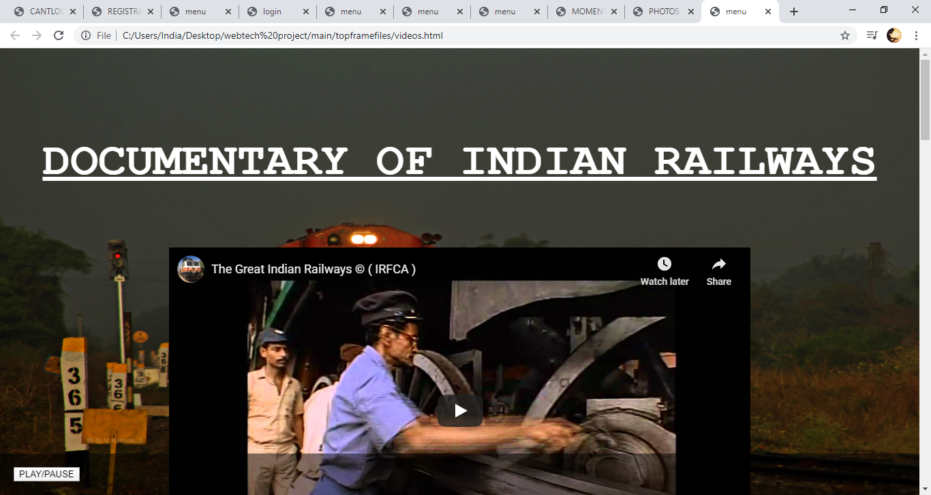

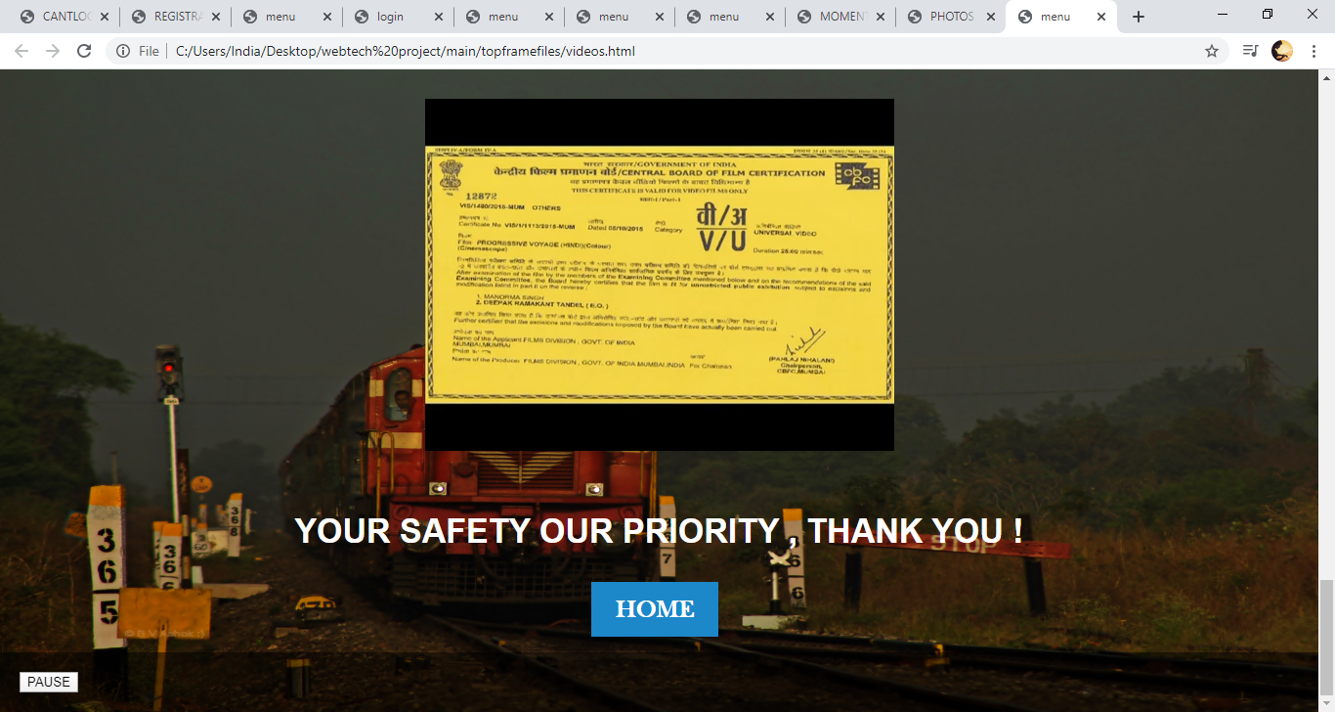

1. HOME

OUTPUT:

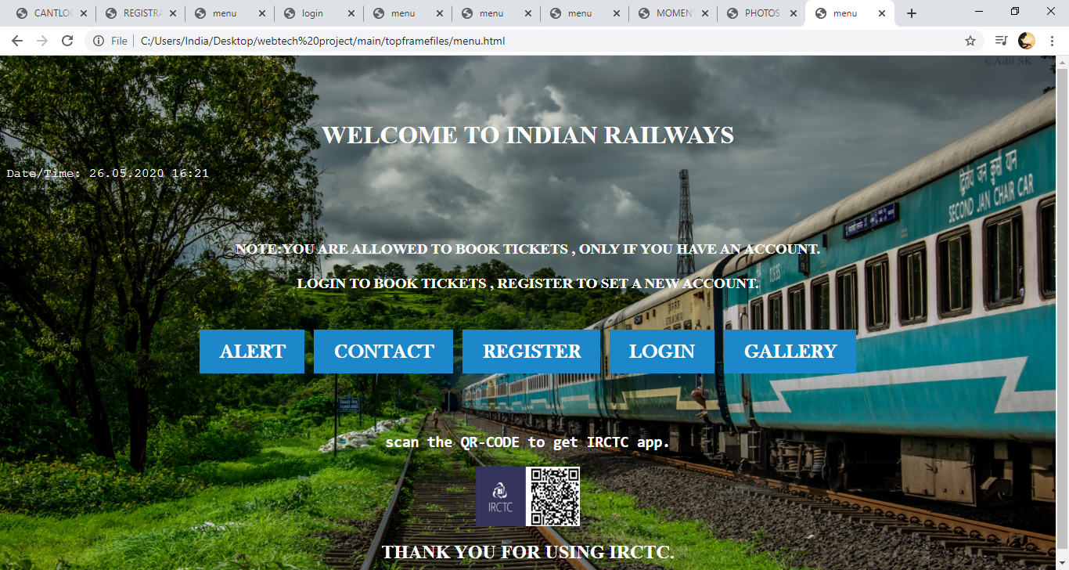

* THANK YOU.

WITH RESPECT AJHAY .V (1931004)

--------------------------